**Practical List 1. Write program to read and display digital image using MATLAB or SCILAB**

**a. Become familiar with SCILAB/MATLAB Basic commands**

**b. Read and display image in SCILAB/MATLAB**

**c. Resize given image**

**d. Convert given color image into gray-scale image**

**e. Convert given color/gray-scale image into black & white image**

**f. Draw image profile**

**g. Separate color image in three R G & B planes**

**h. Create color image using R, G and B three separate planes**

**i. Flow control and LOOP in SCILAB**

**j. Write given 2-D data in image file**

**2. To write and execute image processing programs using point processing method**

**a. Obtain Negative image**

**b. Obtain Flip image**

**c. Thresholding**

**d. Contrast stretching**

**3. To write and execute programs for image arithmetic operations**

**a. Addition of two images**

**b. Subtract one image from other image**

**c. Calculate mean value of image**

**4. To write and execute programs for image logical operations**

**a . AND operation between two images**

**b. OR operation between two images**

**c. Calculate intersection of two images**

**d. NOT operation (Negative image)**

**5. To write a program for histogram calculation and equalization using**

**a. Standard MATLAB function**

**b. Program without using standard MATLAB functions**

**6. To write and execute program for geometric transformation of image**

**a. Translation**

**b. Scaling**

**c. Rotation**

**d. Shrinking**

**e. Zooming**

**7. To understand various image noise models and to write programs for**

**a. image restoration**

**b. Remove Salt and Pepper Noise**

**c. Minimize Gaussian noise**

**d. Median filter**

**8. Write and execute programs to use spatial low pass and high pass filters**

**9. Write and execute programs for image frequency domain filtering**

**a. Apply FFT on given image**

**b. Perform low pass and high pass filtering in frequency domain**

**c. Apply IFFT to reconstruct image**

**10. Write a program in C and MATLAB/SCILAB for edge detection using different edge detection mask**

**11. Write and execute program for image morphological operations erosion and dilation.**

**Question 1:** Write program to read and display digital image using MATLAB or SCILAB

a. Become familiar with SCILAB/MATLAB Basic commands

b. Read and display image in SCILAB/MATLAB

c. Resize given image

d. Convert given color image into gray-scale image

e. Convert given color/gray-scale image into black & white image

f. Draw image profile

g. Separate color image in three R G & B planes

h. Create color image using R, G and B three separate planes

i. Flow control and LOOP in SCILAB

j. Write given 2-D data in image file

**Solution:**

Code -

**(a)**

a=imread("D:\ Tiger.jpg ");

imshow(a);

title("original image");

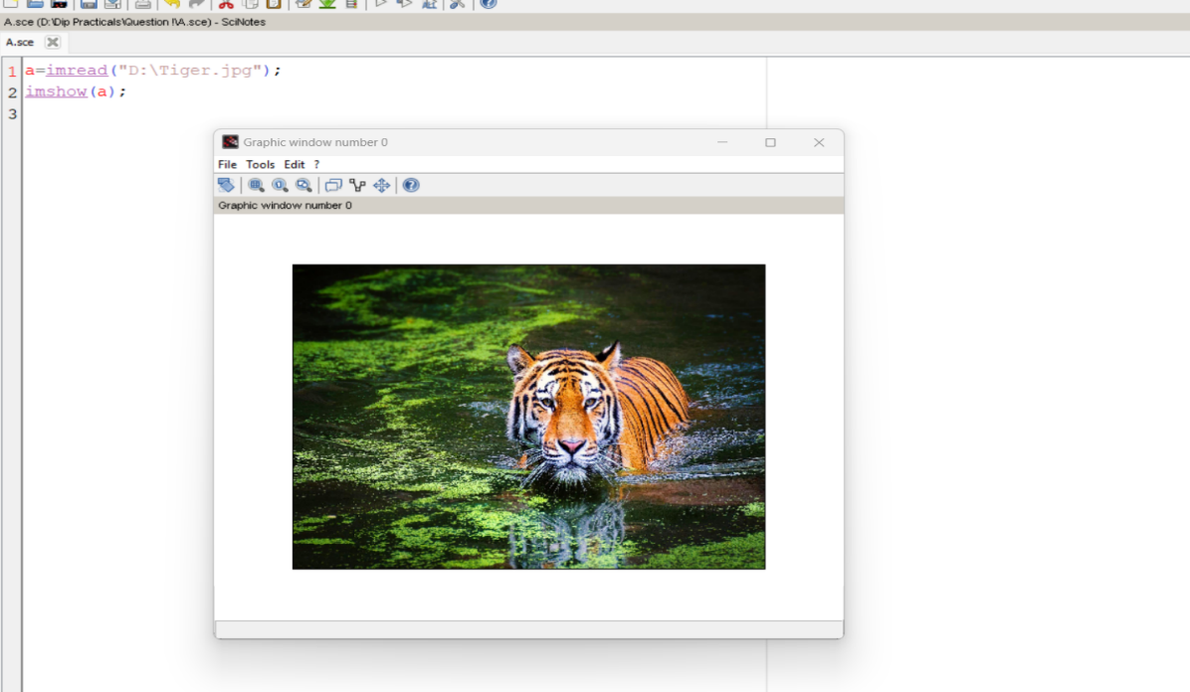

**(b)**

a=imread("D:\ Landscape.jpg ");

imshow(a);

title("original image");

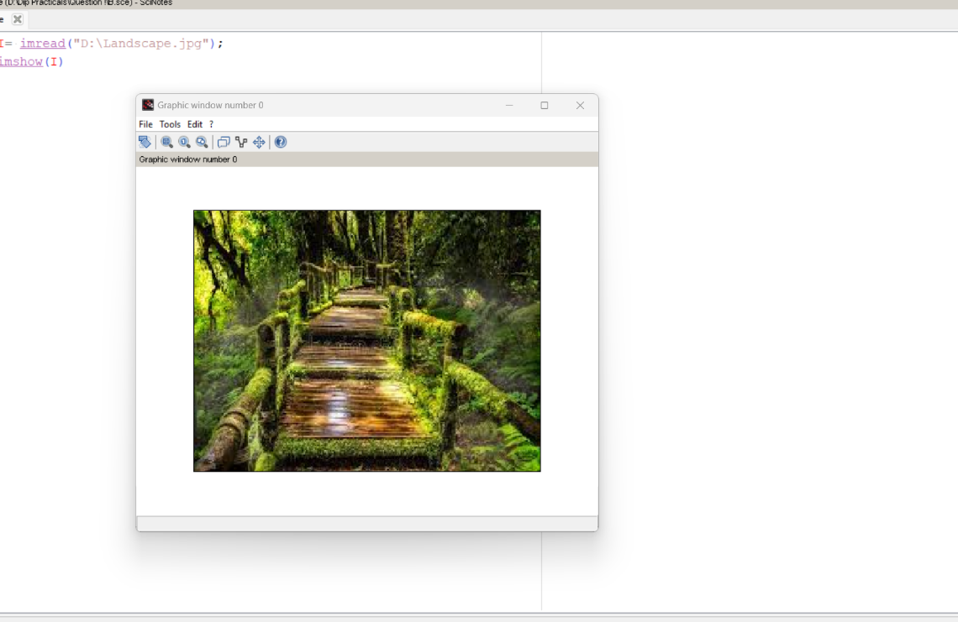

**(c)**

I= imread("D:\ Pic.jpg");

J= imresize(I,0.4);

figure

imshow(I);

title("Original image");

figure

imshow(J);

title("Resized image");

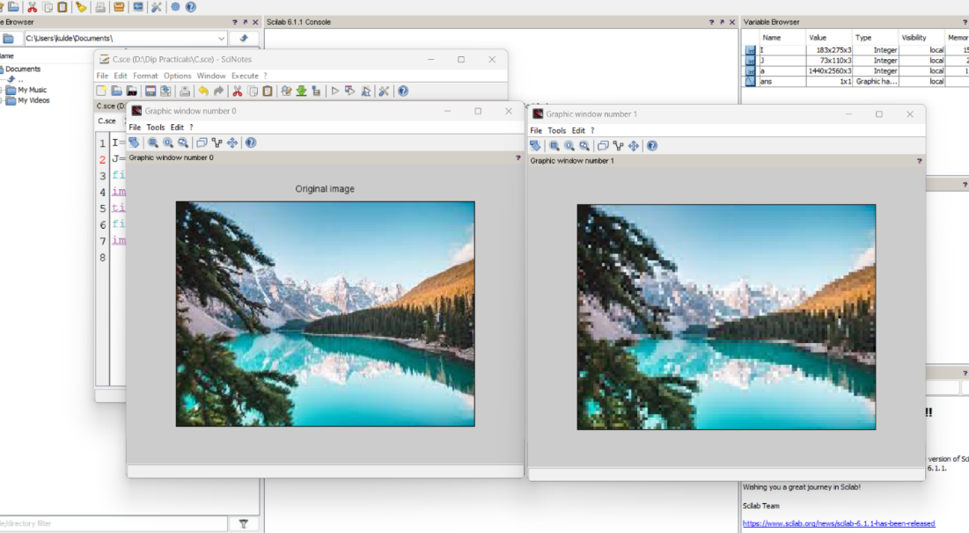

**(d)**

RGB = imread("D:\ Pic.jpg");

figure

imshow(RGB);

title("Original image");

I = rgb2gray(RGB);

figure

imshow(I);

title("gray-scale image");

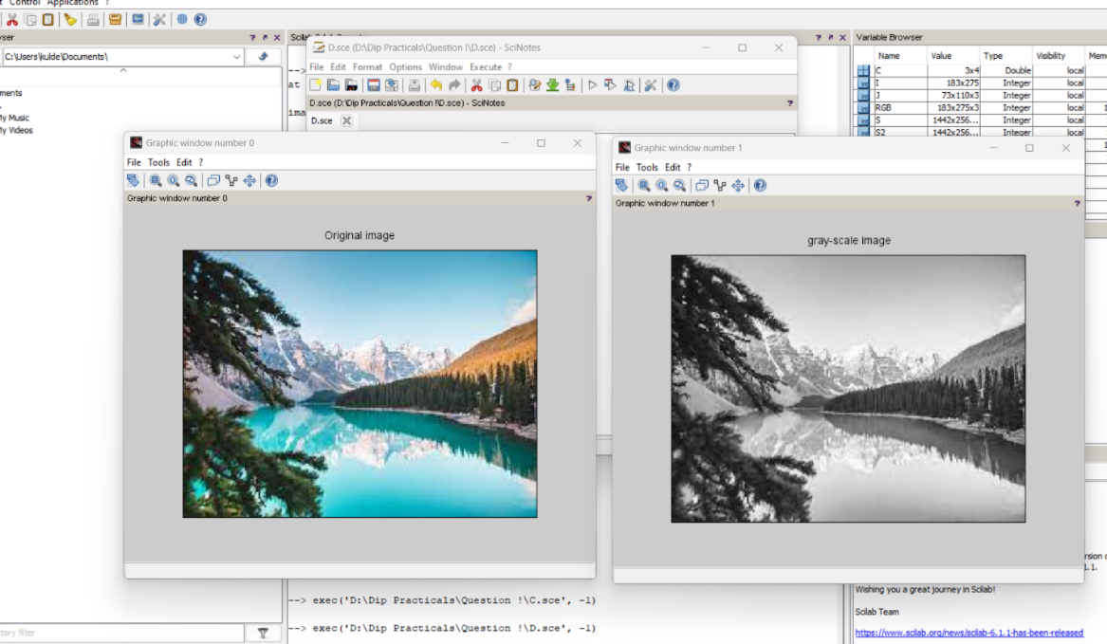

**(e)**

I = imread("D:\ Pic.jpg ");

figure

imshow(I);

title("Original image");

J = im2bw(I,0.5);

figure

imshow(J);

title("Black & White image");

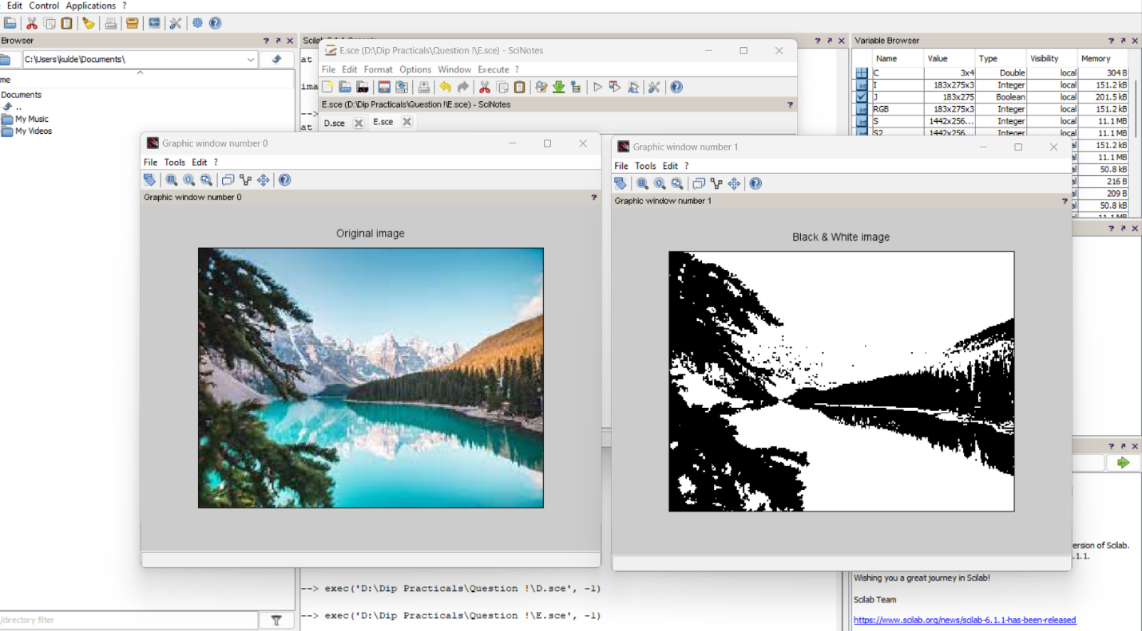

**(f)**

i = imread("D:\ Nature.jpg ");

improfile(i);

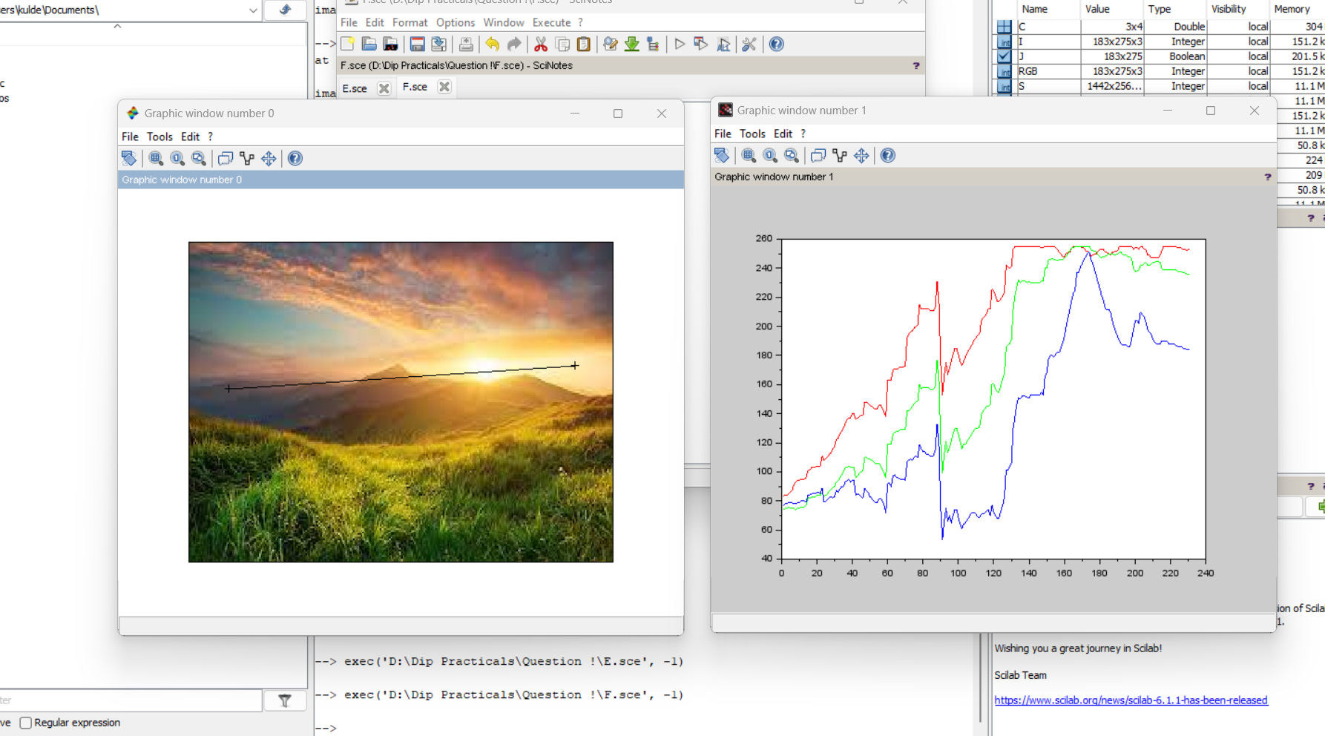

**(g),(h)**

i = imread("D:\Nature.jpg ");

redChannel = i(:,:,1); // Red channel

greenChannel = i(:,:,2); // Green channel

blueChannel = i(:,:,3); // Blue channel

// Create an all black channel.

allBlack = zeros(size(i, 1), size(i, 2), 'uint8');

// Create color versions of the individual color channels.

just_red = cat(3, redChannel, allBlack, allBlack);

just_green = cat(3, allBlack, greenChannel, allBlack);

just_blue = cat(3, allBlack, allBlack, blueChannel);

// Recombine the individual color channels to create the original RGB image again.

recombinedRGBImage = cat(3, redChannel, greenChannel, blueChannel);

// Display them all.

figure

subplot(3, 3, 2);

imshow(i);

fontSize = 2;

title('Original RGB Image', 'FontSize', fontSize)

subplot(3, 3, 4);

imshow(just_red);

title('Red Channel in Red', 'FontSize', fontSize)

subplot(3, 3, 5);

imshow(just_green)

title('Green Channel in Green', 'FontSize', fontSize)

subplot(3, 3, 6);

imshow(just_blue);

title('Blue Channel in Blue', 'FontSize', fontSize)

subplot(3, 3, 8);

imshow(recombinedRGBImage);

title('Recombined to Form Original RGB Image Again', 'FontSize', fontSize)

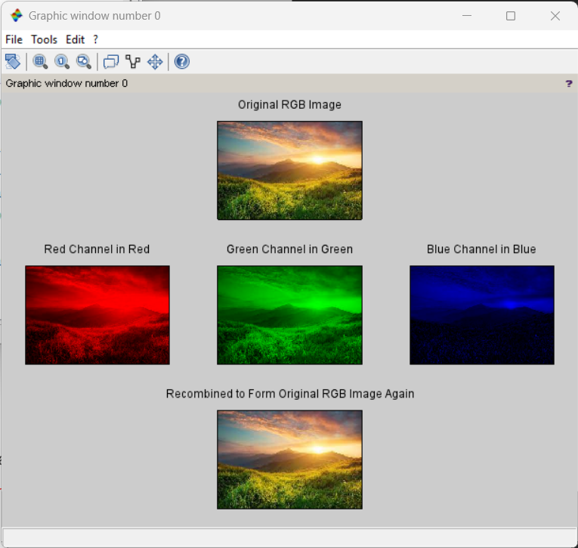

**(i)**

num = input("Enter a Number ");

% Flow Control

% Program to find a Number is even or Odd

if mod(num,2) == 0

disp('The Number is Even');

elseif mod(num,2) ~=0

disp('The Number is Odd');

else

disp('Invalid Number');

end

% Loop

% Program to generate Bipolar signal +1 / -1

mat = rand(1,10,'single');

binary =zeros(size(mat));

for count = 1:1:length(mat)

if mat(count) >= 0

binary(count) =1;

else

binary(count) =-1;

end

end

disp("Bipolar Signal ")

disp(binary)

Output :

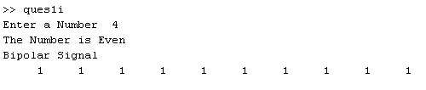

**(j)**

C = [0 2 4 6; 8 10 12 14; 16 18 20 22];

image(C)

colorbar

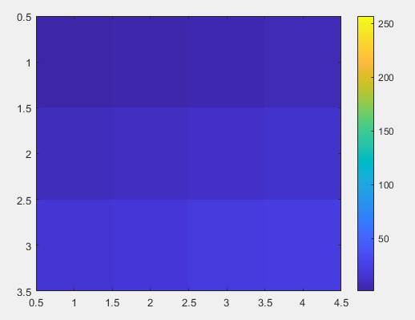

**Question 2:** To write and execute image processing programs using point processing method

a. Obtain Negative image

b. Obtain Flip image

c. Thresholding

d. Contrast stretching

**Solution:**

Code -

**(a)**

a=imread("D:\Tiger.jpg");

figure

imshow(a);

title("Original Image")

d=255-a;

figure

imshow(d);

title("Negative Image")

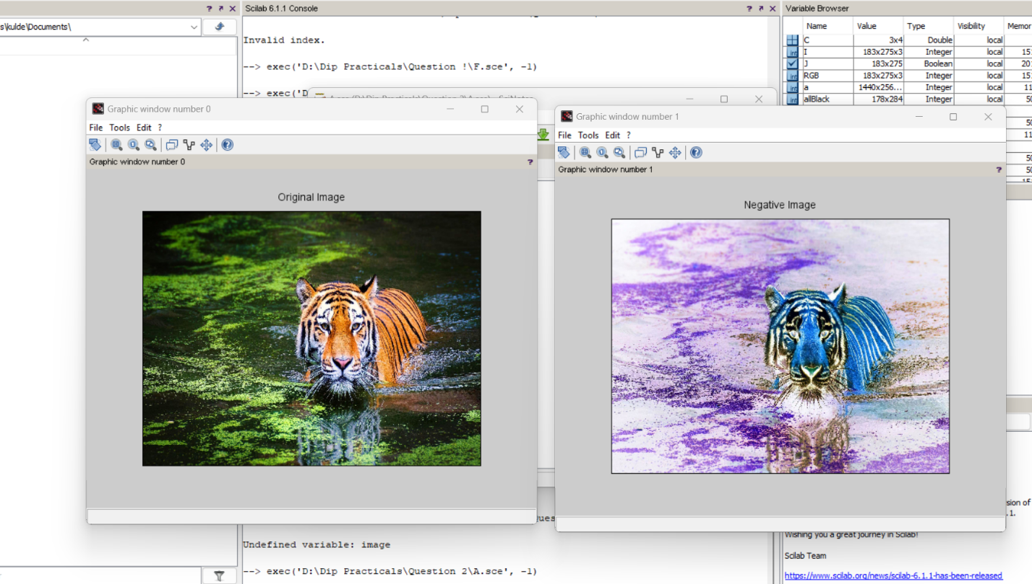

**(b)**

I=imread("D:\Tiger.jpg ");

S2 = imrotate(I,180);

imshow(S2);

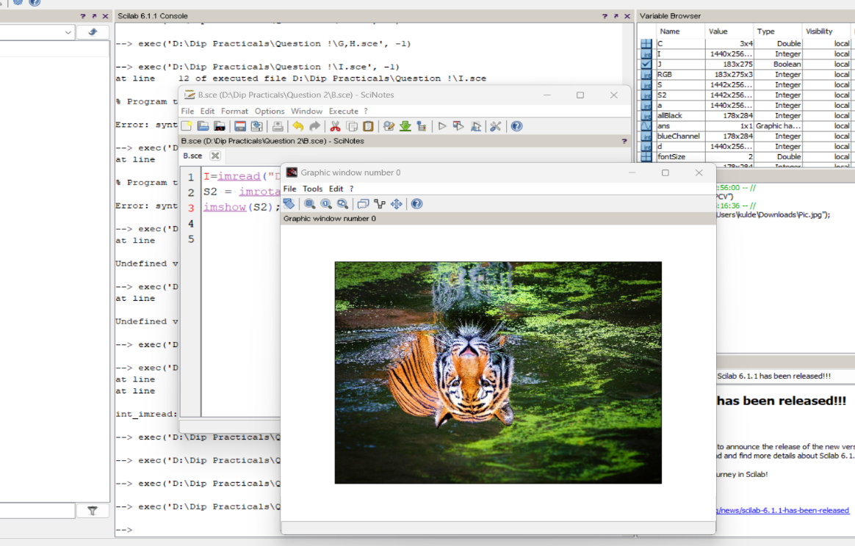

**(c)**

I = imread("D:\einstein.jpg");

% Convert the image into a binary image.

BW = imbinarize(I);

% Display the original image next to the binary version.

figure

imshowpair(I,BW,'montage')

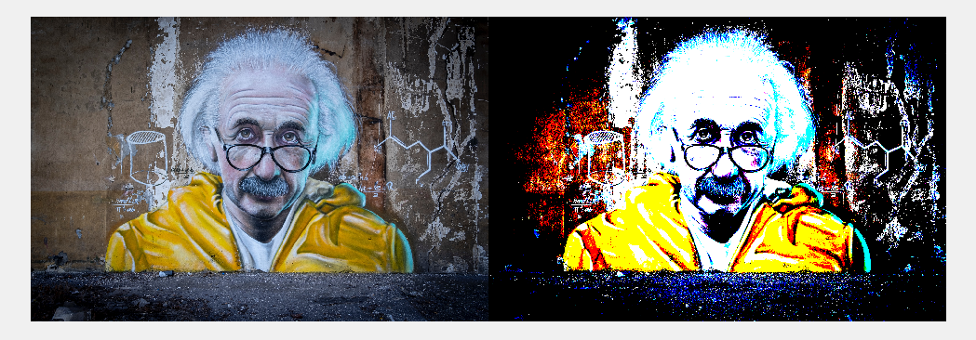

**(d)**

X=imread("D:\Pic.jpg");

//X = imread('image.jpg'); //%reading a grayscale image

figure(1);

imshow(X);

title('Original Image')

a = min(X(:)); // %minimum pixel of image X

b = max(X(:)); //%maximum pixel of image X

X= (X-a).*(255/(b-a)); //%just using the formula above

figure(2);

imshow(X);

title('Contrast Streached Image')

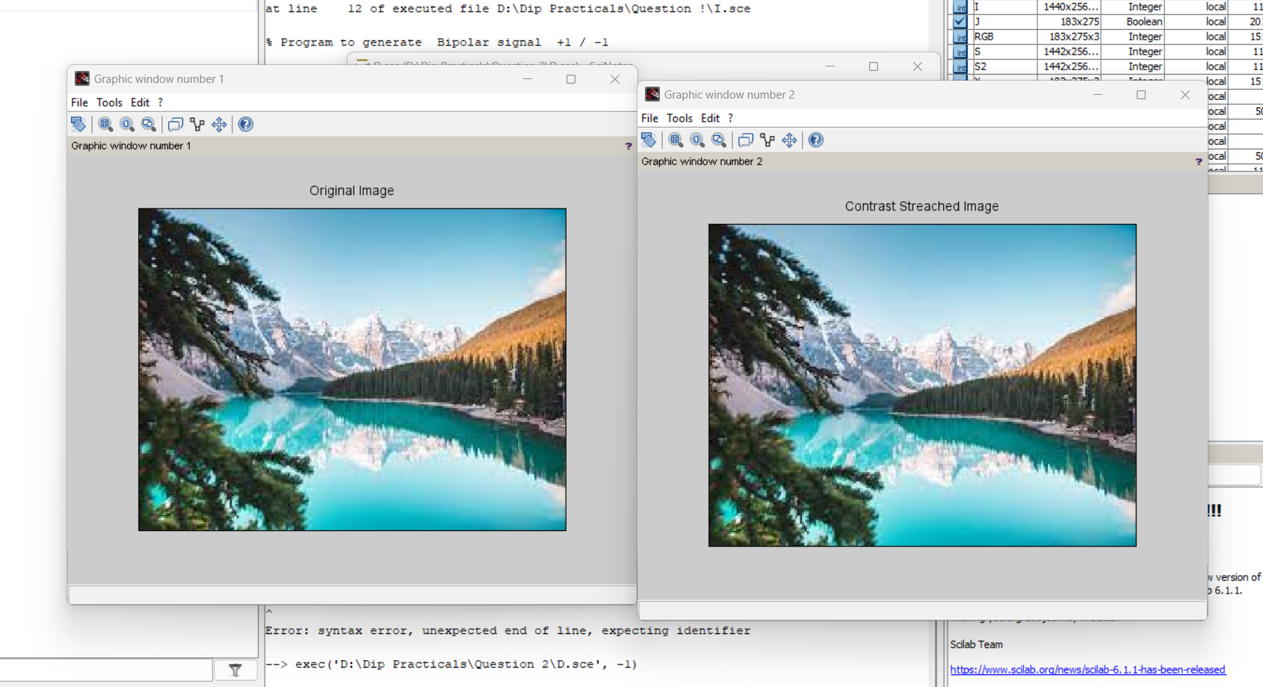

**Question 3:** To write and execute programs for image arithmetic operations

a. Addition of two images

b. Subtract one image from other image

c. Calculate mean value of image

**Solution:**

Code -

**(a)**

%Read two grayscale uint images into the workspace.

im1=imread("D:\Nature.jpg");

im2=imread("D:\Nature1.jpg");

subplot(1,2,1), title('Image 1'), imshow(im1);

subplot(1,2,2), title('Image 2'), imshow(im2);

im3 = imadd(im1, im2);

imshow(im3);

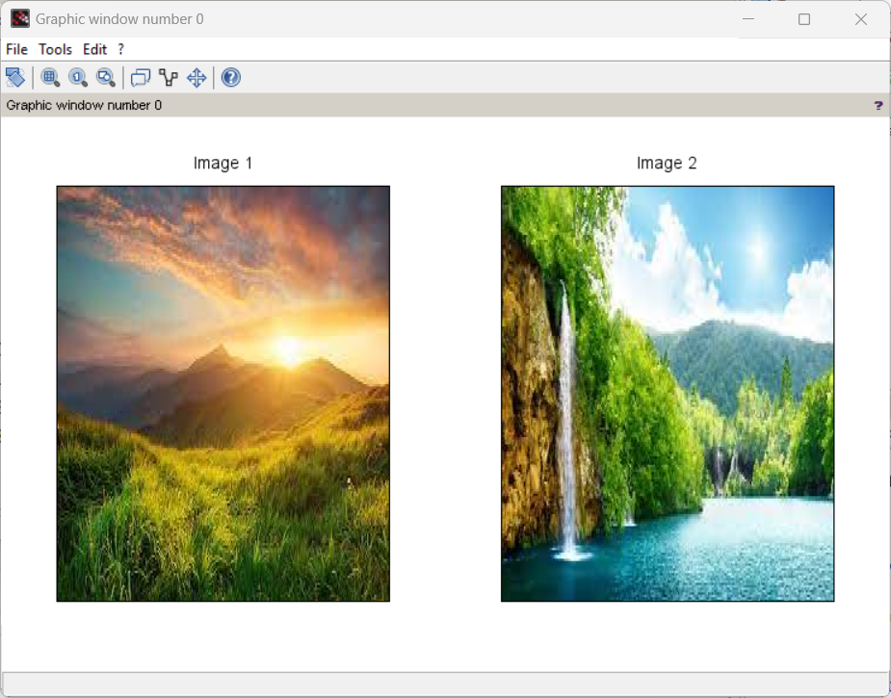

**(b)**

im4 = im1 - im2;

im5 = im2 - im1;

subplot(1,3,1), title('Image 3 = Image 1 + Image 2'), imshow(im3);

subplot(1,3,2), title('Image 4 = Image 1 - Image 2'), imshow(im4);

subplot(1,3,3), title('Image 5 = Image 2 - Image 1'), imshow(im5);

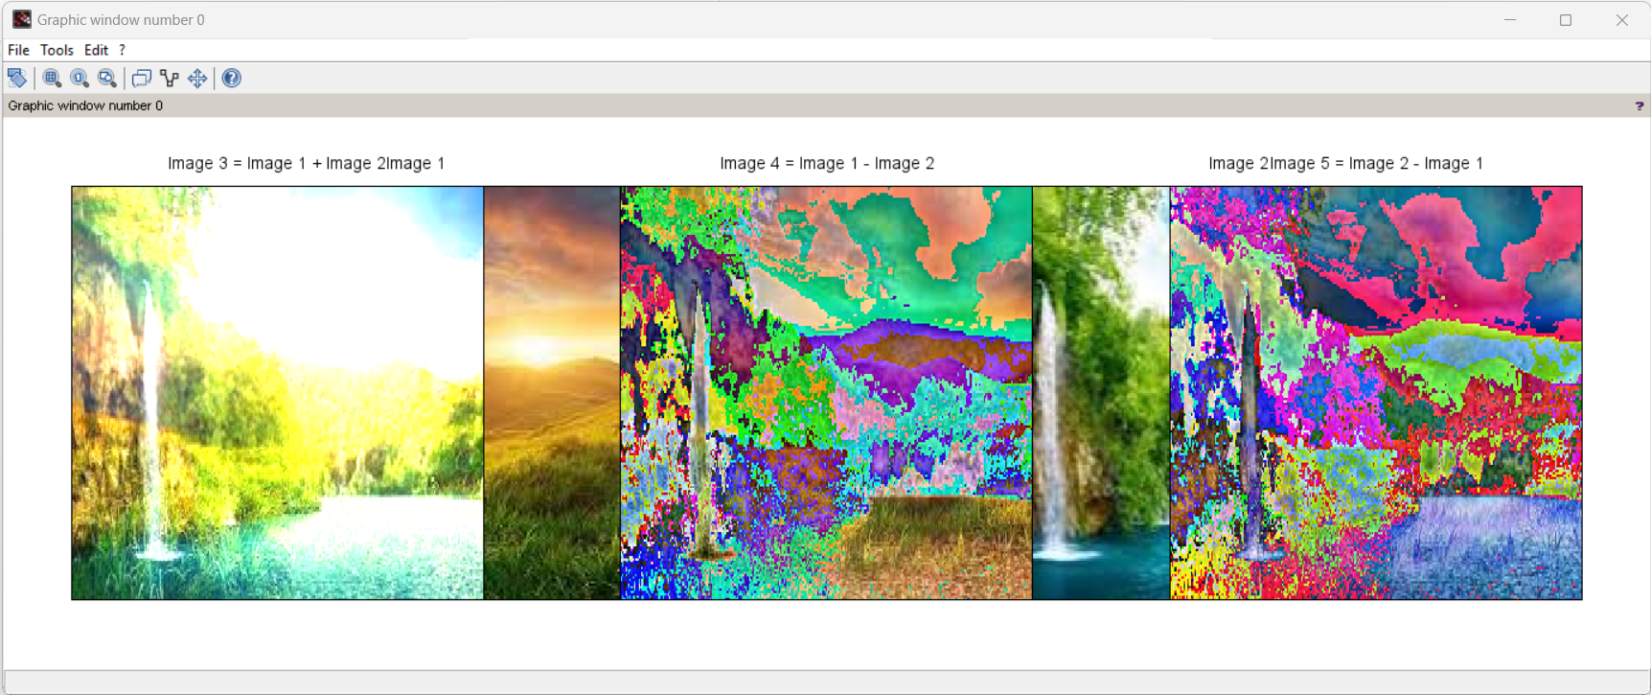

**(c)**

printf('Mean of the image 1 : %.3f\n',mean(im2double(im1)));

printf('Mean of the image 2 : %.3f',mean(im2double(im2)));

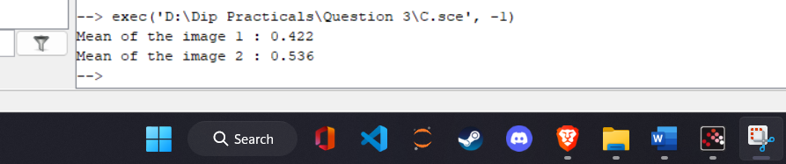

**Question 4:** To write and execute programs for image logical operations

a. AND operation between two images

b. OR operation between two images

c. Calculate intersection of two images

d. NOT operation (Negative image)

**Solution:**

Code -

(a)

i= imread('D:\f1.jpg');

j= imread('D:\f2.jpg');

andimage=imabsdiff(i,j);

imshow(andimage);

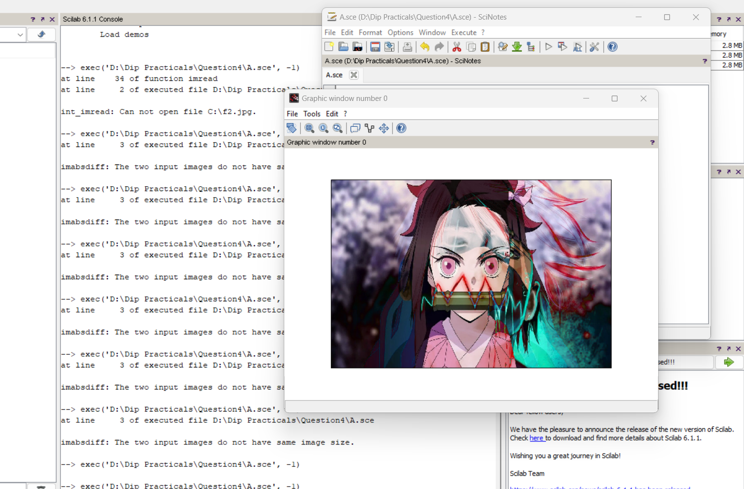

**(b)**

i= imread('D:\f1.jpg');

j= imread(‘D:\f2.jpg');

orimage=bitor(i,j);

imshow(orimage);

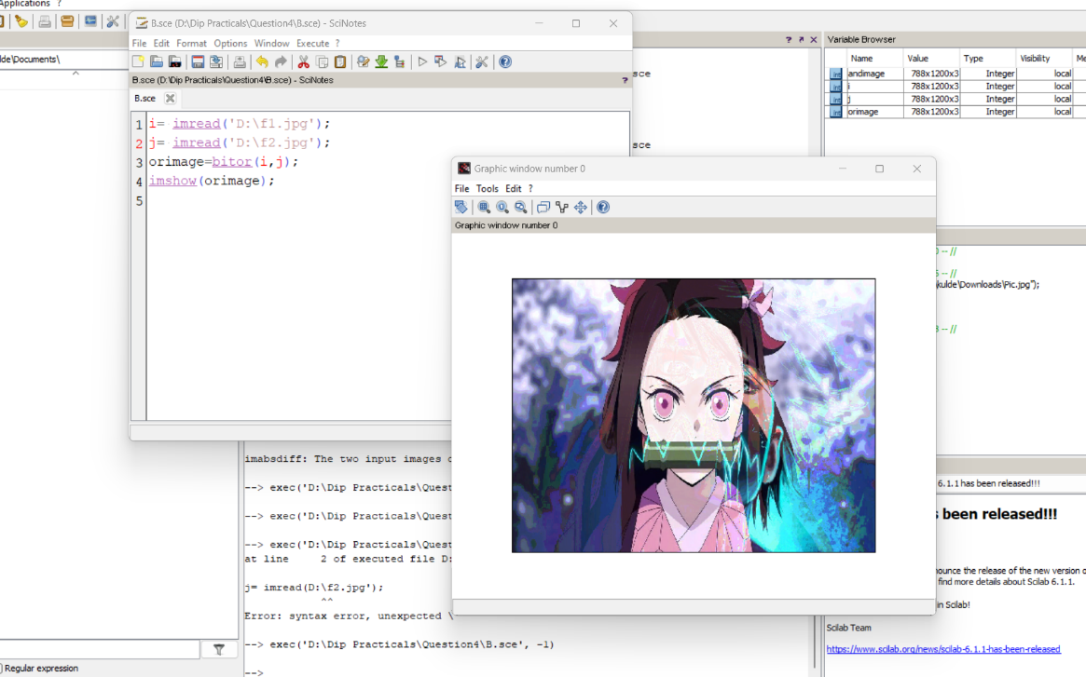

**(c)**

a= imread('D:\f1.jpg');

b=imread(D:\f2.jpg');

intersectedImage=bitand(a,b);

subplot(2,2,3), imshow(a), title('rice');

subplot(2,2,4), imshow(b), title('smile');

subplot(2,2,2), imshow(intersectedImage), title('Intersection');

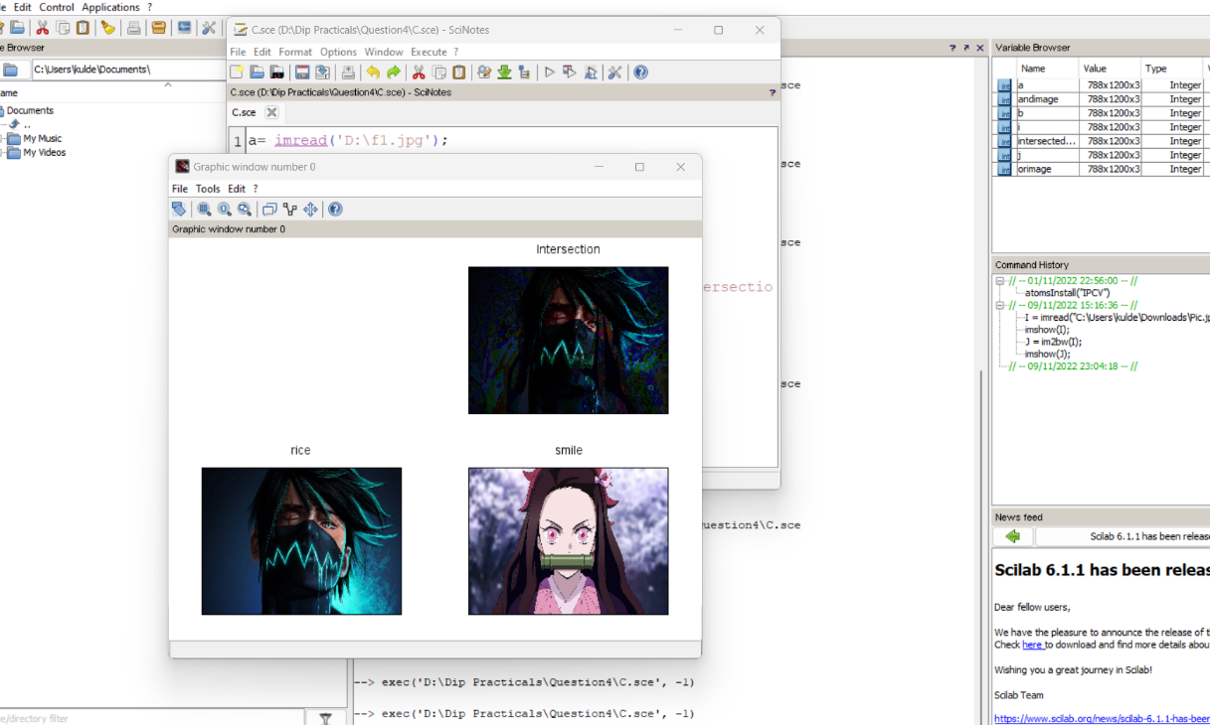

**(d)**

W= imread('D:\f1.jpg');

NotW= bitcmp(W);

figure

subplot(1,2,1)

imshow(W)

title("cat")

subplot(1,2,2)

imshow(NotW)

title("NOT Operation")

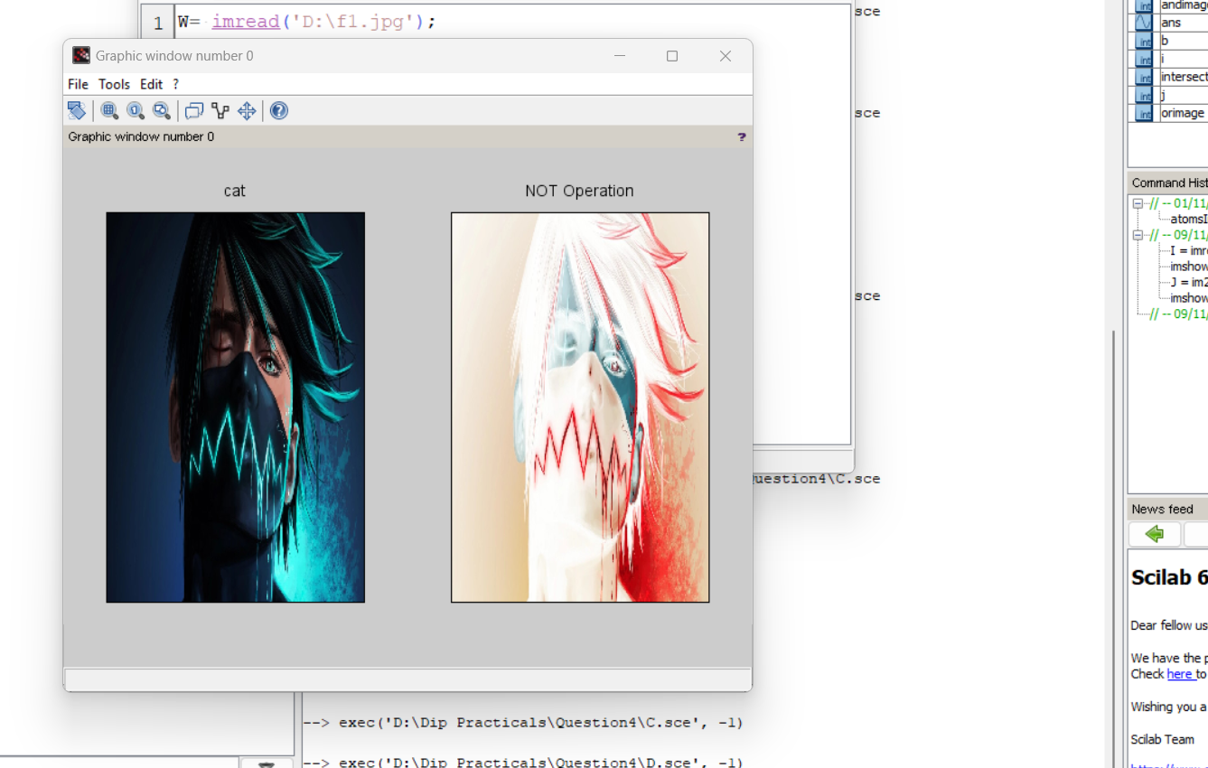

**Question 5:** To write a program for histogram calculation and equalization using

a. Standard MATLAB function

b. Program without using standard MATLAB functions

**Solution:**

Code -

**(a)**

I= rgb2gray(imread("D:\Pic.jpg"));

subplot(2,2,1);

imshow(I);

subplot(2,2,2);

imhist(I,[],1);

J=imhistequal(I);

subplot(2,2,3);

imshow(J);

subplot(2,2,4);

imhist(J,[], 1);

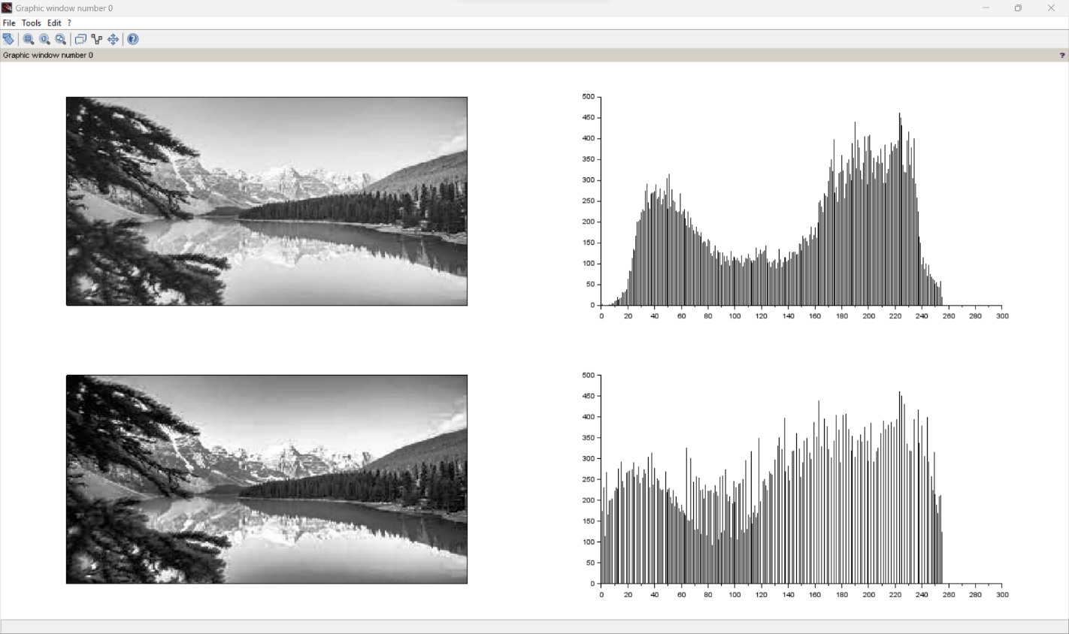

**(b)**

GIm=imread('D:\penguin.jpg');

numofpixels=size(GIm,1)*size(GIm,2);

figure

imshow(GIm);

title('Original Image');

HIm=uint8(zeros(size(GIm,1),size(GIm,2)));

freq=zeros(256,1);

probf=zeros(256,1);

probc=zeros(256,1);

cum=zeros(256,1);

output=zeros(256,1);

//freq counts the occurrence of each pixel value.

//The probability of each occurrence is calculated by probf.

for i=1:size(GIm,1)

for j=1:size(GIm,2)

value=GIm(i,j);

freq(value+1)=freq(value+1)+1;

probf(value+1)=freq(value+1)/numofpixels;

end

end

sum=0;

no_bins=255;

//The cumulative distribution probability is calculated.

for i=1:size(probf)

sum=sum+freq(i);

cum(i)=sum;

probc(i)=cum(i)/numofpixels;

output(i)=round(probc(i)*no_bins);

end

for i=1:size(GIm,1)

for j=1:size(GIm,2)

HIm(i,j)=output(GIm(i,j)+1);

end

end

figure,imshow(HIm);

title('Histogram equalization');

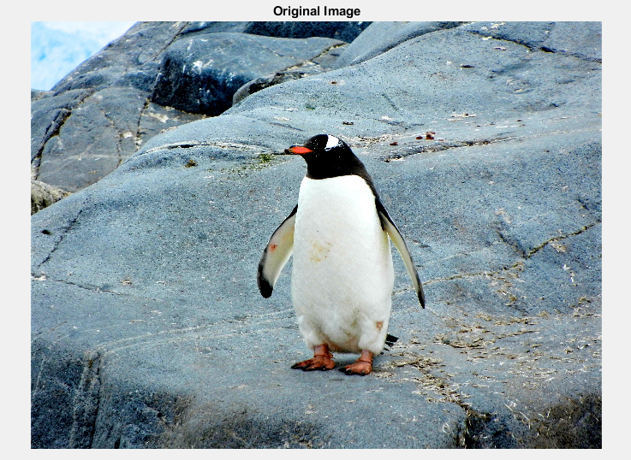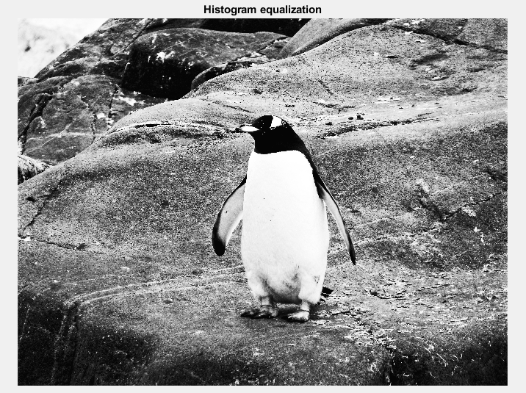

**Question 6:** To write and execute program for geometric transformation of image

a. Translation

b. Scaling

c. Rotation

d. Shrinking

e. Zooming

**Solution:**

Code -

**(a)**

S1=imread("D:\Nature.jpg");

mat = [ 1 0 0;...

0 1 0;...

20 0 1];

S2 = imtransform(S1,mat,'affine');

mat = [ 1 0 0;...

0 1 0;...

0 -20 1];

S3 = imtransform(S1,mat,'affine');

mat = [ 1 0 0;...

0 1 0;...

-20 30 1];

S4 = imtransform(S1,mat,'affine');

subplot(2,2,1), title('Original Image'), imshow(S1);

subplot(2,2,2), title('Translation for x = 20'), imshow(S2);

subplot(2,2,3), title('Translation for y = -20'), imshow(S3);

subplot(2,2,4), title('Translation for (-20,30)'), imshow(S4);

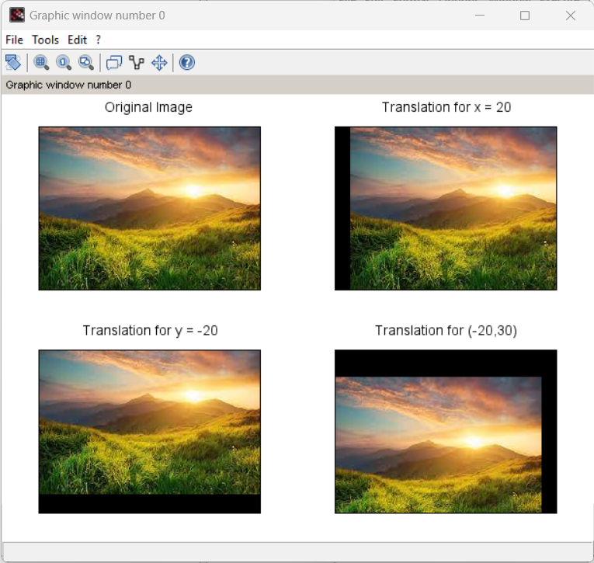

**(b)**

s_img=imread("D:\f2.jpg ");

width = size(s_img, 'c');

height = size(s_img, 'r');

w = 2;

h = 1;

mat = [ w 0;

0 h;

0 0];

sc1 = imtransform(s_img, mat, 'affine', width*w, height*h);

w = 1;

h = 2;

mat = [ w 0;

0 h;

0 0];

sc2 = imtransform(s_img, mat, 'affine', width*w, height*h);

w = 2;

h = 2;

mat = [ w 0;

0 h;

0 0];

sc3 = imtransform(s_img, mat, 'affine', width*w, height*h);

function s = str(img)

s = 'Size : ' + strcat(string(size(img)), ' * ');

endfunction;

subplot(3,3,1), title('Original Image'), xlabel(str(s_img)), imshow(s_img);

subplot(3,2,2), title('Image scaling width by 2'),xlabel(str(sc1)), imshow(sc1);

subplot(2,3,4), title('Image scaling height by 2'),xlabel(str(sc2)), imshow(sc2);

subplot(2,2,4), title('Image scaling by 2'),xlabel(str(sc3)), imshow(sc3);

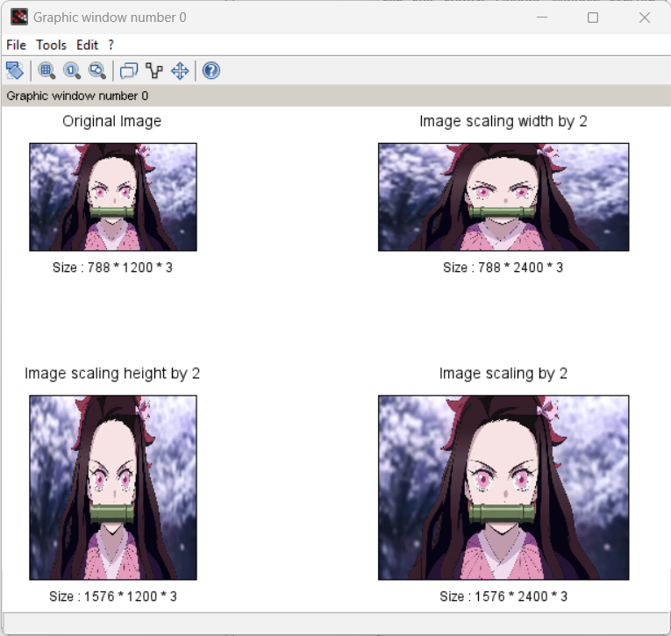

**(c)**

img1 =imread("D:\Pic.jpg");

i =imrotate(img1,[45]);

//%Original image

subplot(3,1,1);

imshow(img1);

title("Original Image");

subplot(3,1,2);

imshow(i);

title("Rotate Image");

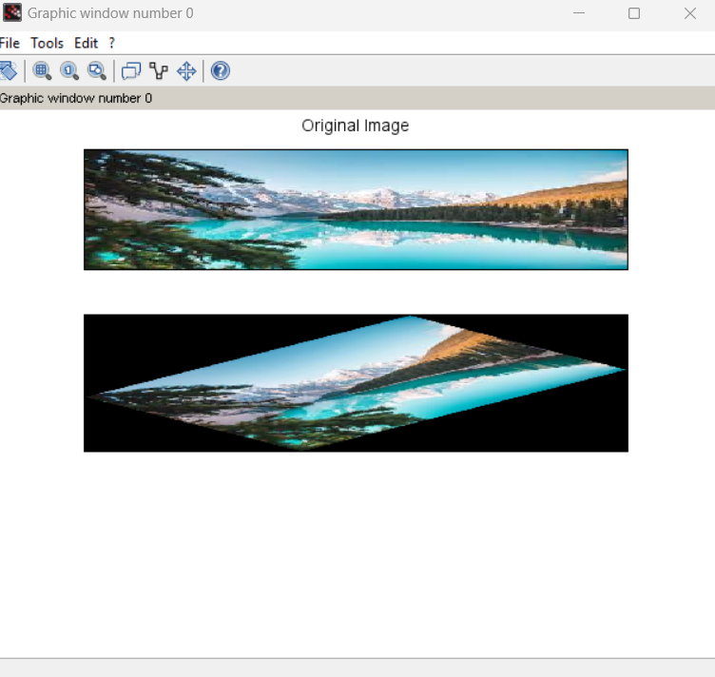

**(d)**

im_50 = imresize(s_img, 0.5);

im_sw = imresize(s_img, [height, 100]);

im_sh = imresize(s_img, [150, width]);

subplot(2,2,1), title('Original Image'), xlabel(str(s_img)), imshow(s_img);

subplot(2,3,3), title('Image with Shrinked Width'),xlabel(str(im_sw)), imshow(im_sw);

subplot(3,2,5), title('Image with Shrinked Height'),xlabel(str(im_sh)), imshow(im_sh);

subplot(3,3,9), title('Image Shrinked by 50%'),xlabel(str(im_50)), imshow(im_50);

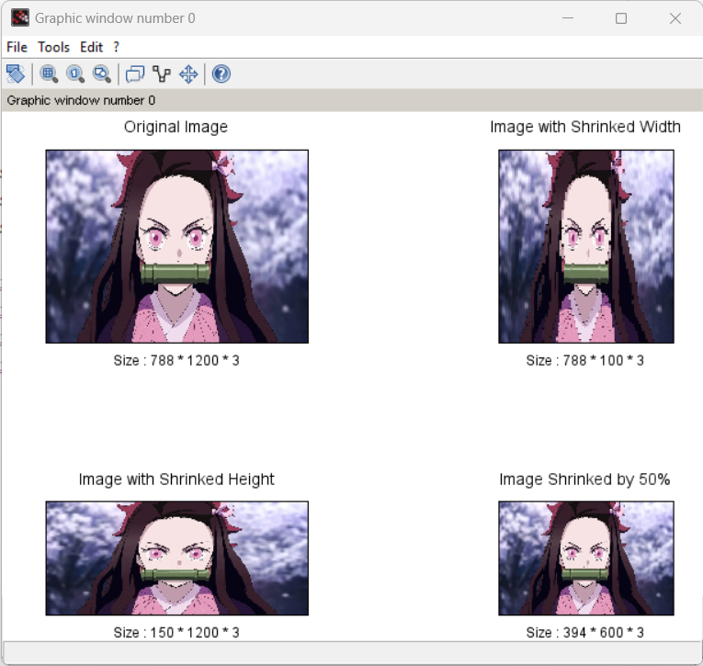

**(e)**

img6=imread("D:\Cat.jpg");

[m,n,colormap]=size(img6);

if colormap==3

x=img6(:,:,1);

y=img6(:,:,2);

z=img6(:,:,3);

end

c=[];

k =1;

l =1;

f =input('Enter the replication factor by which the image is to be Zoomed:');

for i=1:m

for t=1:f

for j=1:n

for t=1:f

if colormap==3

c1(k,l)=x(i,j);

c2(k,l)=y(i,j);

c3(k,l)=z(i,j);

else

c(k,l)=b(i,j);

end

l=l+1;

end

end

l=1;

k=k+1;

end

end

if colormap==3

c1(:,:,1)=c1;

c2(:,:,2)=c2;

c3(:,:,3)=c3;

end

//%Original image

figure;

imshow(img6);

title("Original Image(256,256)");

//%Zoomed image

figure;

imshow(c);

title('Zoomed Image(512,512)');

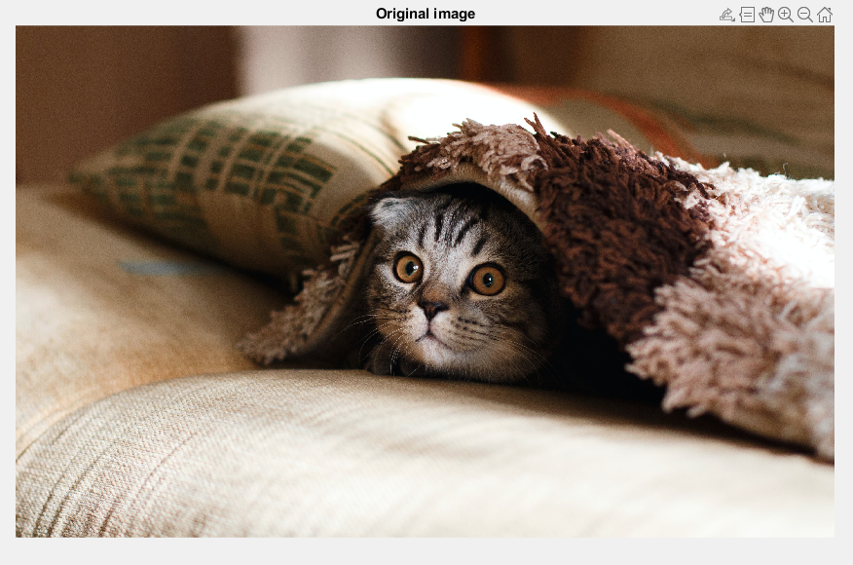

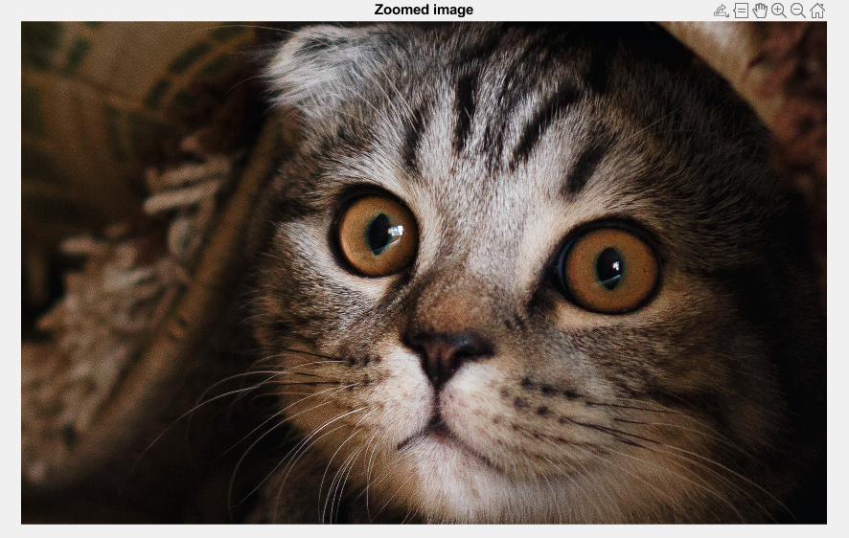

**Question 7:** To understand various image noise models and to write programs for

a. image restoration

b. Remove Salt and Pepper Noise

c. Minimize Gaussian noise

d. Median filter

**Solution:**

Code -

**(a)**

im1=imread("D:\lava.jpg");

im= imresize(im1,[125 125]);

S= convn(im1,ones(125,125)/15625,'same');

[Dx,Dy]=gradient(S);

figure,imshow(im1);

title("Original Image");

figure,imshow(im);

title("Restored Image");

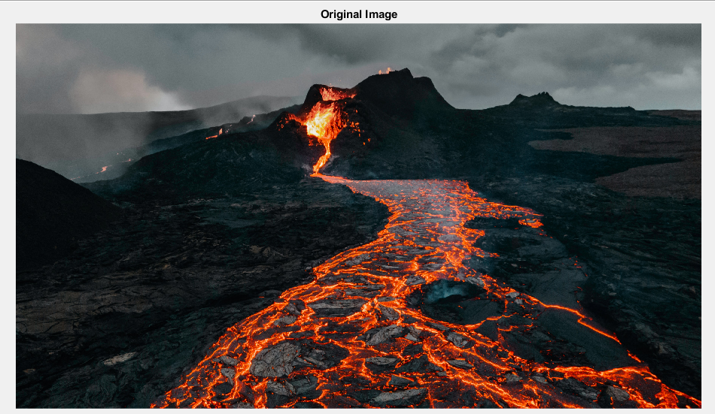

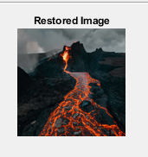

**(b)**

I=imread(“D:\Landscape.jpg");

figure

imshow(I)

title("Original Image")

J = imnoise(I,'salt & pepper',0.02);

figure

imshow(J)

title("Updated Image")

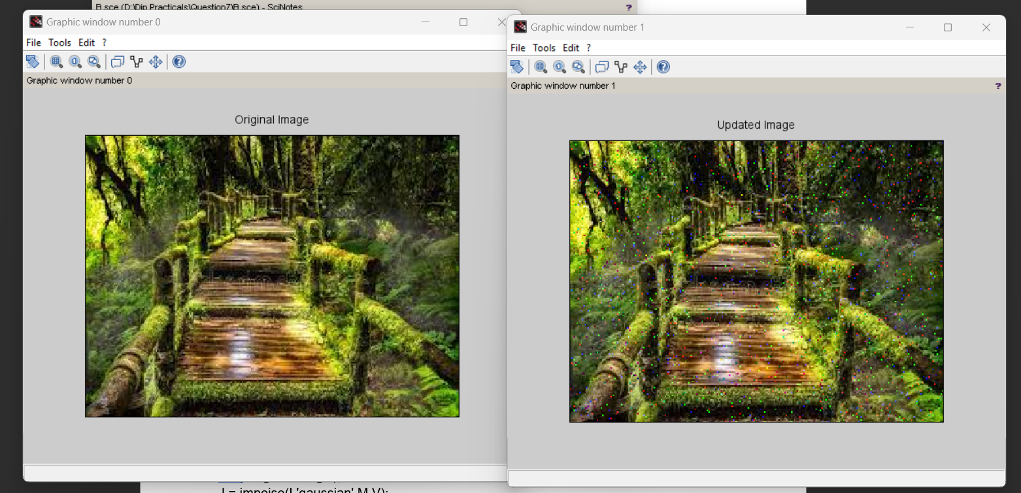

**(c)**

I=imread("D:\Landscape.jpg");

M =0;

V=0.01;

imshow(I);

title('Original Image');

J = imnoise(I,'gaussian',M,V);

figure,imshow(J);

title('Gaussian Noise');

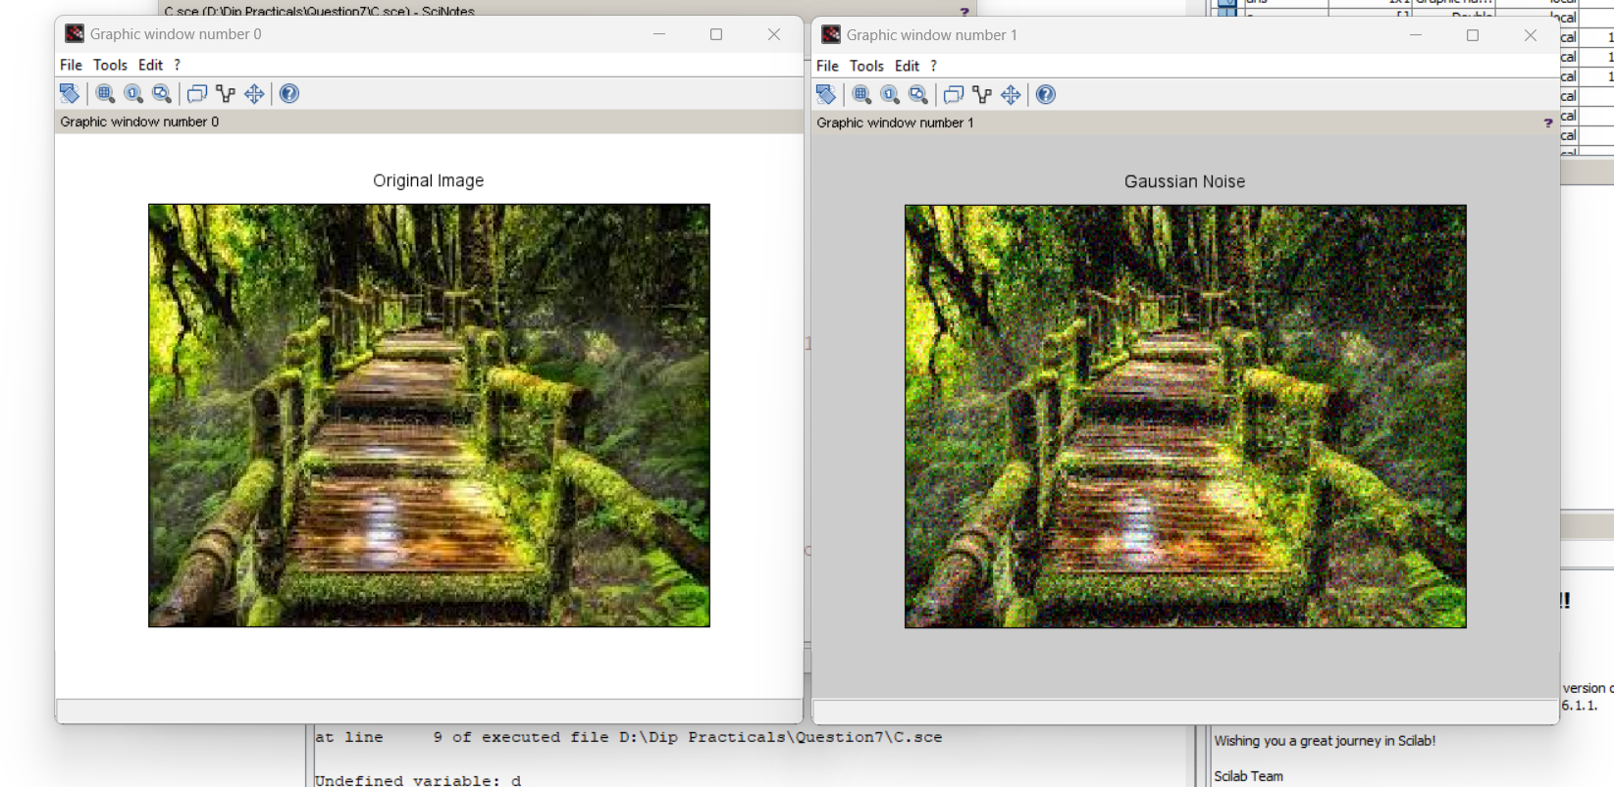

**(d)**

RGB=imread("D:\Landscape.jpg");

I = rgb2gray(RGB);

imshow(I);

title('Original GrayScale Image');

J = imnoise(I,'gaussian',0,0.025);

figure();

imshow(J);

title('Portion of the Image with Added Gaussian Noise');

K = wiener2(J,[5 5]);

figure();

imshow(K);

title('Portion of the Image with Noise Removed by Wiener Filter');

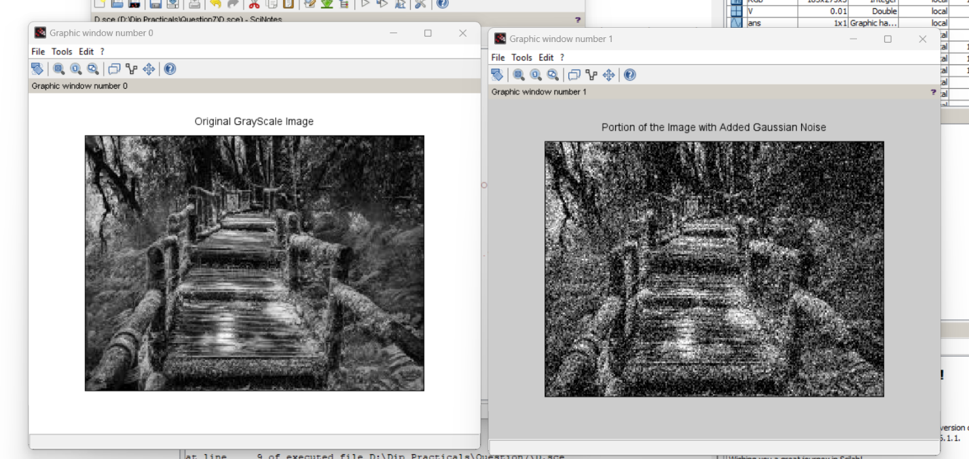

**Question 8:** Write and execute programs to use spatial low pass and high pass filters.

**Solution:**

Code -

//High pass

i1= imread('D:\Pic.jpg');

g_filter = fspecial('gaussian');

i2 = imfilter(i1, g_filter);

g_filter2 = fspecial('gaussian', [8,8], 10);

i3 = imfilter(i1, g_filter2);

g_filter3 = fspecial('gaussian',[25,25], 31);

i4 = imfilter(i1, g_filter3);

subplot(2,2,1), title('Original Image'), imshow(i1);

subplot(2,2,2), title('Default Gaussian kernel'), imshow(i2);

subplot(2,2,3), title('Gaussian kernel with 8 * 8 with sigma = 10'), imshow(i3);

subplot(2,2,4), title('Gaussian kernel with 25 * 25 with sigma = 31'), imshow(i4);

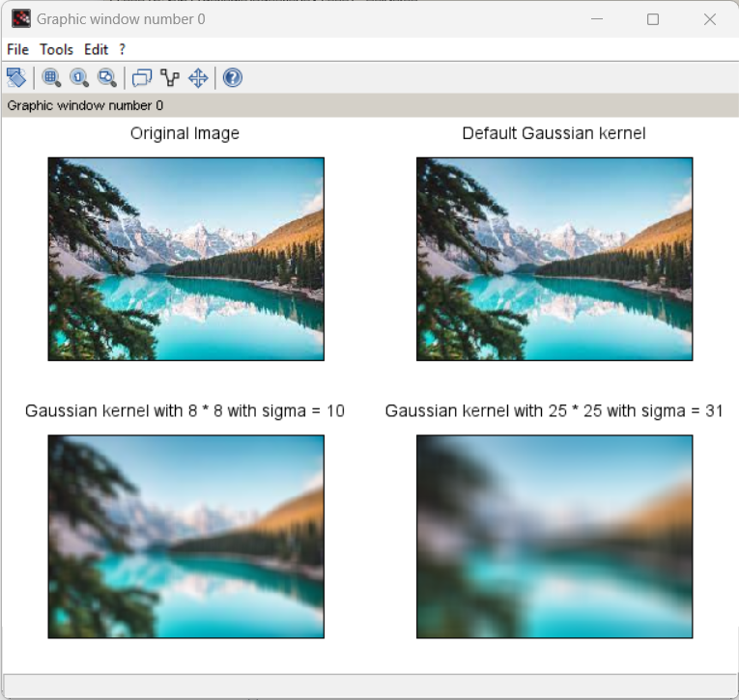

//low pass

i1=imread("D:\Pic.jpg");

l_filter = fspecial('laplacian');

i2 = imfilter(i1, l_filter);

subplot(1,2,1), title('Original Image'), imshow(i1);

subplot(1,2,2), title('Laplacian Filter'), imshow(i2);

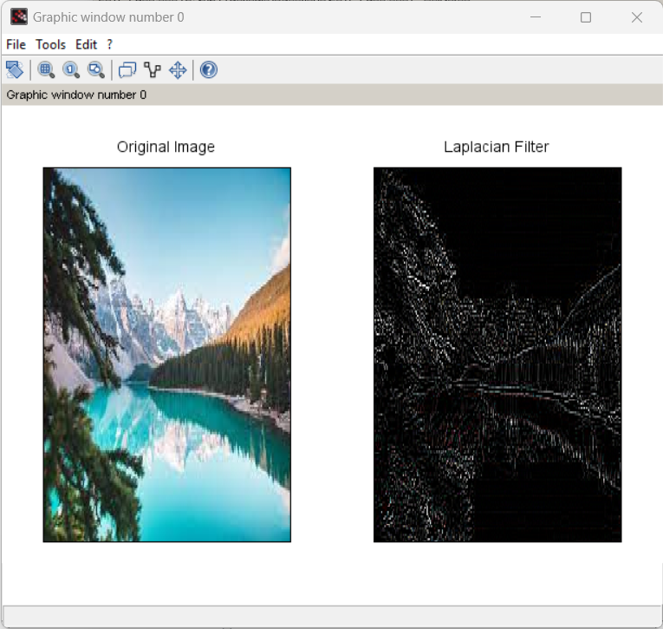

**Question 9:** Write and execute programs for image frequency domain filtering

a. Apply FFT on given image

b. Perform low pass and high pass filtering in frequency domain

c. Apply IFFT to reconstruct image

**Solution:**

Code -

**(a)**

// Read in image.

I=imread("D:\Nature1.jpg");

grayImage = rgb2gray(I);

figure,imshow(grayImage);

title("Original Image");

FF = fft(grayImage);

figure,imshow(FF);

title("FFT Image");

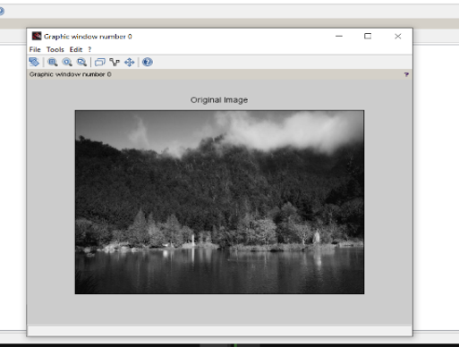

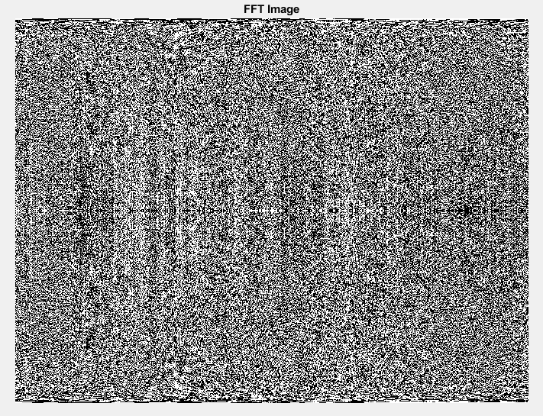

**(b)**

**(i) Low Pass Filtering**

img=imread("D:\girl.jpg");

gimg=rgb2gray(img);

subplot(331)

imshow(gimg)

title('f(x,y)')

//%% Ideal low pass

P=size(gimg);

M=P(1);N=P(2);

F=fft2(gimg,M,N);

subplot(332)

//%imshow(uint8(abs(fftshift(F))));

imshow(uint8(abs((F))));

title('F(u,v)')

(u>M/2);

u(idx)=u(idx)-M;

idy=find(v>N/2);

v(idy)=v(idy)-N; u0=100; %remove freq greater than u0

u=0:(M-1);

v=0:(N-1);

idx=find

[V,U]=meshgrid(v,u);

D=sqrt(U.^2+V.^2);

H=double(D<=u0);

//% display

subplot(333)

imshow(abs(fftshift(H)),[]);

title('H(u,v) ILPF')

subplot(334)

G=H.*F;

g=(ifft2(G));

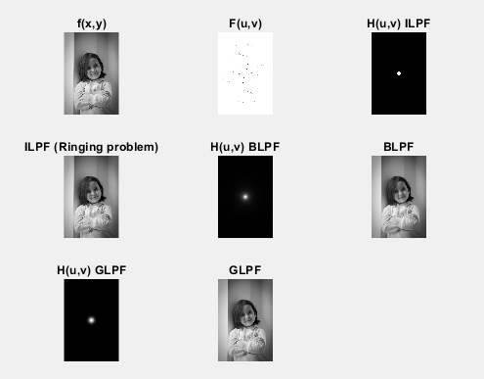

**(ii) High Pass Filtering**

img=imread('girl.jpg');

gimg=rgb2gray(img);

subplot(331)

imshow(gimg)

title('f(x,y)')

%% Ideal high pass

P=size(gimg);

M=P(1);N=P(2);

F=fft2(gimg,M,N);

subplot(332)

%imshow(uint8(abs(fftshift(F))));

imshow(uint8(abs(F)));

title('F(u,v)')

u0=50; %remove freq greater than u0

u=0:(M-1);

v=0:(N-1);

idx=find(u>M/2);

u(idx)=u(idx)-M;

idy=find(v>N/2);

v(idy)=v(idy)-N;

[V,U]=meshgrid(v,u);

D=sqrt(U.^2+V.^2);

H=1-double(D<=u0);

% display

subplot(333)

imshow(abs(fftshift(H)),[]);

title('H(u,v) IHPF')

subplot(334)

G=H.*F;

g=(ifft2(G));

imshow(histeq(uint8(g)),[])

title('IHPF (Ringing problem)')

%% Butterworth high pass

n=1; %Butterworth filter of order n

H=1-(1./(1 + (D./u0).^(2*n)));

subplot(335)

imshow(abs(fftshift(H)));

title('H(u,v) BHPF')

subplot(336)

G=H.*F;

g=(ifft2(G));

imshow(histeq(uint8(g)),[])

title('BHPF')

%% Gaussian high pass filter

H =1- (exp(-(D.^2)./(2*(u0^2))));

subplot(337)

imshow(abs(fftshift(H)));

title('H(u,v) GHPF')

subplot(338)

G=H.*F;

g=(ifft2(G));

imshow(histeq(uint8(g)),[])

title('GHPF')

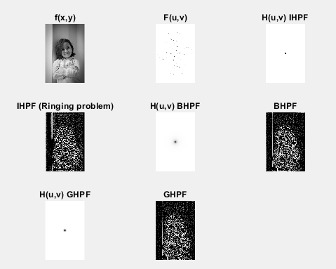

**(c)**

//Read in the image you want

I = imread('penguin.jpg');

figure, imshow(I);

title("Original Image")

//Extract and binarize the relevant colour channels

redChannel=imbinarize(I(:,:,1), 0.8);

greenChannel=imbinarize(I(:,:,2), 0.4);

//Filter the image

filtered = medfilt2(redChannel+greenChannel);

//Convert to binary mask

mask=imbinarize(filtered,0.3);

//Apply the mask to the colour channels

Ir = I(:,:,1); Ir(~mask)=0;

Ig = I(:,:,2); Ig(~mask)=0;

Ib = I(:,:,3); Ib(~mask)=0;

//Compile the output image

I_coloured(:,:,1) = Ir;

I_coloured(:,:,2) = Ig;

I_coloured(:,:,3) = Ib;

figure

imshow(I_coloured)

title("Reconstructed Image")

Finding IFFT

IFF = ifft(I_coloured);

figure,imshow(IFF)

title("iFFT image")

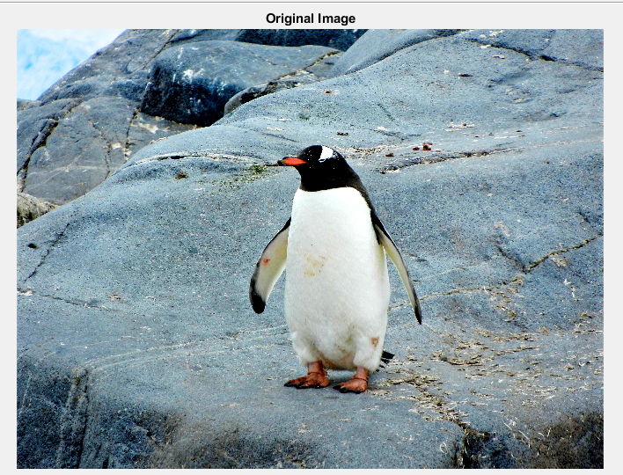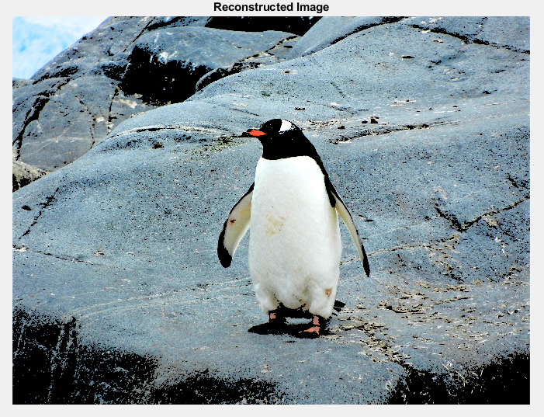

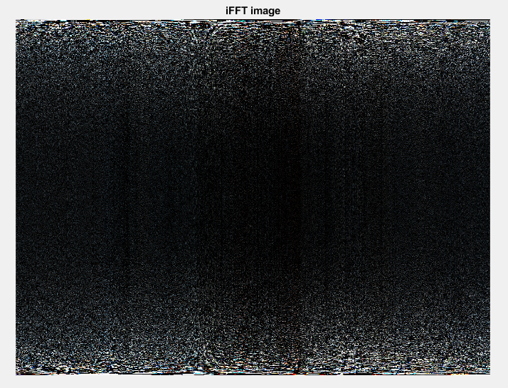

**Question 10:** Write a program in C and MATLAB/SCILAB for edge detection using different edge

detection mask.

**Solution:**

Code -

i= imread('D:\Tiger.jpg');

I=rgb2gray(i);

BW1=edge(I,"prewitt");

BW2=edge(I,"sobel");

BW3=edge(I,"roberts");

subplot(2,2,1);

imshow(I);

title("original");

subplot(2,2,2);

imshow(BW1);

title("Prewitt");

subplot(2,2,3);

imshow(BW2);

title("Sobel");

subplot(2,2,4);

imshow(BW3);

title("Roberts");

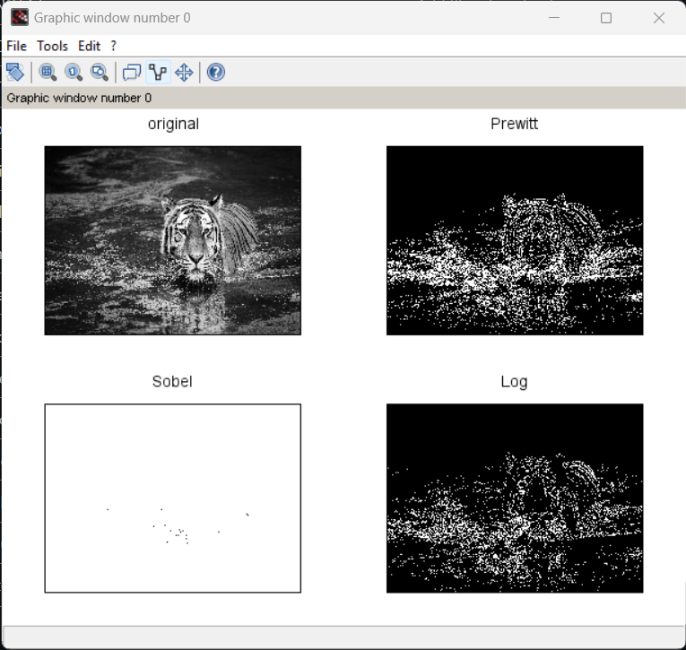

**Question 11:** Write and execute a program for image morphological operations erosion and dilation.

**Solution:**

Code -

I1= imread('D:\Landscape.jpg');

I=im2bw(I1,0.5);

se=imcreatese('cross',3,3);

subplot(2, 3, 1);

imshow(I);

title("Original image");

dilate = imdilate(I, se);

subplot(2, 3, 2);

imshow(dilate);

title("Dilated image");

erode = imerode(I, se);

subplot(2, 3, 3);

imshow(erode);

title("Eroded image");

